North American Refuge: Comparing U.S. and Canadian Refugee Economic Self-Sufficiency
Paul Scholes
Texas A&M University

This paper compares refugee resettlement outcomes in the United States and Canada, focusing on public assistance usage. Using data from the U.S. Annual Survey of Refugees and Canada’s Longitudinal Immigration DataBase, I compare the effectiveness of private groups, government-directed-nonprofit-implemented, and a blend of government and private resettlement systems. The findings indicate that government-assisted refugees in both countries have similar public assistance usage rates, with an average 2.24 percentage point difference at the end of five years. Government-led programs in both countries had the highest rates of public assistance use. Canada’s private sponsorship resettlement program shows the lowest public assistance rates. A gender gap exists, with female-headed households more likely to use public assistance. The U.S. achieves comparable outcomes to Canada despite investing less in resettlement per household. These results suggest that the structure of resettlement programs, especially the private sponsorship program in Canada, plays a crucial role in refugee integration and short-term public assistance reliance. This is a timely and pertinent finding for the recent suspension and review of the American private resettlement system based on the Canadian model: the Welcome Corps.

Countries can have multiple paths for immigration and migrants. One of particular emphasis in North America are the refugee resettlement systems. The United States and Canada have (permanently) resettled more refugees every year than the rest of the world combined since at least 1982 (Connor 2019). The United States and Canada resettled about 80,000 of the approximately 114,000 refugees permanently resettled throughout the world in 2022 (International Organization For Migration 2023). The U.S. alone resettles more refugees than the rest of the world combined for all the years from 1982-2024 but two. While Canada does not resettle nearly as many refugees in absolute terms, it leads the world on refugee resettlement per resident for several years, fluctuating around 756 refugees per million residents (Connor 2019). North America is the center of permanent resettlement of refugees to new countries. Note this does not include the many countries who host many more refugees on a temporary basis. When refugees are given permanent residence, it is usually to North America. Despite the broad applicability and unique geographic clumping of North American resettlement, research typically explores resettlement at smaller levels of analysis. This paper fills a gap by providing a comparison of refugee household outcomes across the U.S. and Canada, particularly focusing on public assistance usage.
While much work has focused on the resettlement experience on an individual level (Teixeira and Li 2009), comparisons between the U.S. and Canadian resettlement systems have been limited mostly to analysis of policies between or affecting both countries (e.g., the Safe Third Country Agreement) (Kneebone and Rawlings-Sanaei 2007) or highlighting the differences between policies (Donato and Ferris 2020). Little is known about economic self-sufficiency outcomes across countries, though work has analyzed refugee outcomes in either country alone. While some researchers encourage “juxtaposing Canada and the United States, two countries more similar to each other than any other, … to probe how particular variations can produce consequential differences” (Bloemraad 2011:1131) others worry that similarities are only superficial and so comparisons between the U.S. and Canada are not wise (DeSipio 2011).
This project analyzes refugee households resettled to the United States or Canada and their public assistance program usage. I estimate the effects of arrival cohort, resettlement system, country of resettlement, sex of household head, and country-level funding. To do this, I use multi-level models supplemented with a life table analysis for comparisons of outcomes between the two countries. I also investigate the comparability of U.S. and Canadian refugee data. I find that multilevel models are better than OLS models in this case because of the clustering inside of each country and additionally inside of each resettlement program.
There are reasons to expect that Canadian and U.S. outcomes would be different. Canada supports their refugees with refugee-specific support for a year, but the U.S. only has automatic refugee-specific assistance for 90 days. Afterwards refugees resettled through the U.S. have access to the social safety net available to any other citizen (and cash assistance may be available at the state level), but no automatic monetary assistance. In addition to its government-led system, Canada also has a private system where private groups sponsor and support refugees. Researchers have hypothesized the advantage having local and social supports may have on the resettlement process (Phillimore 2020; Strang and Ager 2010). Additionally, Canada has a blended resettlement program where households receive two rounds of six-month support from government and private sources respectively. I find that more financial support per capita did not predict better economic self-sufficiency rates at the end of five years. The resettlement systems that supported households for longer also did not have better outcomes at the end of five years.
I use the Annual Survey of Refugees to obtain estimates for refugees resettled to the United States. This survey samples refugees who arrived in the past five years and has publicly available data for years 2016-2020. I obtain the complementary Canadian refugee cohorts from the longitudinal Immigration Database along with information on program funding available from U.S. and Canadian government expenditure reports.
This analysis has implications for policy and theory. While many researchers are concerned that U.S. refugees may not be achieving their full potential because they do not have the resources up front to invest in their full potential (Capps et al. 2015; Fix et al. 2017), the Canadian case does not suggest that more spending per household, nor longer duration of refugee specific support, is related to better economic self-sufficiency outcomes at the end of five years. It is important to note that these assertions are usually applied to the long term, which is not within the scope of this study. In other words, this study only examines the relationship of variables in the short term, and it is probable that long term public assistance use is predicted by spending per capita or duration of refugee-specific support in the long run.
The Trump administration recently suspended the U.S. Refugee Admissions Program to review whether its existence is aligned with U.S. interests (The White House 2025). The U.S. government-led resettlement system is usually the largest and most efficient per-capita resettlement program in the world. While there is no data on the new U.S. Welcome Corps, it is inspired by the Canadian private-led program. And assuming the observed comparability between the U.S. and Canadian government-led resettlement program holds, the Welcome Corps is likely even more efficient in conserving tax dollars and rapidly helping refugees become independent contributors to the tax base and their communities.
BACKGROUND
Economic Self-Sufficiency among Refugees
Economic self-sufficiency is when someone or a household of people can live on their own funds and do not use public assistance programs. Economic self-sufficiency is a central goal of the U.S. resettlement system: “resettlement agencies focus on assisting refugees to achieve economic self-sufficiency” (United States Department of State 2021:1). Immigration, Refugees, and Citizenship Canada “Core Responsibility #2” is (in part) “the admission and economic and social integration of immigrants and refugees…” (Immigration, Refugees, and Citizenship Canada 2023:20).
The idea that newcomers would come to a country and not contribute their fair share has been a concern for Americans since at least the first public charge law of 1882. Public charge laws continue to this day in the United States under the Public Charge Grounds Final Rule (2022 Final Rule) (U.S. Department of Homeland Security 2022). This concern has motivated the focus on economic self-sufficiency in migration generally. This focus is often misapplied to other migrants, who are not allowed to use public assistance at all, but refugees are given access to support programs upon arrival. Refugees are also unique in that they are given permanent residence status at the end of their first year. Refugee households are eligible for public assistance programs upon arrival to the United States and do not have to wait or change their status (Food and Nutrition Service of the U.S. Department of Agriculture 2024).
Canada is also concerned about public assistance program use. Potential immigrants can be found inadmissible if a medical condition “causes excessive demand on health or social services”. An immigrant can be barred from entry for financial reasons – “if (they are) unable or unwilling to support (themselves or their) family members” (Immigration, Refugees, and Citizenship Canada 2010:1). Personal net worth is a considered factor for admission under the economic migration system (Immigration, Refugees, and Citizenship Canada 2010).
Many researchers encourage a front-end-loaded-assistance paradigm. By offering households plenty of resources when they first arrive, households should be able to use those resources to adapt quicker and more effectively (Capps et al. 2015; Evans and Fitzgerald 2017), thereby improving the match between job and worker (Scholes 2022; Sumption 2013), or letting households invest in their skills (English, job, academic, etc.) before entering the workforce permanently (Tran and Lara-García 2020). This assertion leads to hypothesis 1: Resettlement systems that invest more money should have higher self-sufficiency rates at the end of the observation window.
Research on refugee public assistance use has sparked debates among public policy think tanks. However, academic work generally finds that refugees, while using more public assistance programs than others at first, are not drains on the system in the long term, often controlling for other variables like education and English language proficiency (Bose 2020; Donato and Ferris 2020; Evans and Fitzgerald 2017; Nam et al. 2021). The work done by policy think tanks is more debated. For example, the Migration Policy Institute has published a number of reports arguing that U.S. refugee integration is happening in outcomes like employment rates or income levels and refugees are contributing to their communities (Capps et al. 2015; Fix et al. 2017). However, the Center for Immigration Studies often puts out reports focusing on areas where migrants are not assimilating like welfare program use or political incorporation and makes claims like refugees are “importing poverty” (Camarota 1999:1, but also 2021). Similar arguments can be made for the Canadian case. For many outcomes, migrants and refugees attain similar outcomes to natives, like employment. In other areas, like welfare, refugee use rates are higher than natives. The use of multiple outcomes of interest leads to multiple interpretations on the value or cost of resettling refugees.
This project speaks to these debates by expanding the debate to include comparisons with Canada and see if different resettlement systems return different results. These comparisons then allow us to explore why certain policies may be more effective in reaching the shared goal of successful refugee integration.
Comparisons Between Canada and the United States
Some researchers call for more comparisons between the U.S. and Canada, especially in migration outcomes (Bloemraad 2011, 2013). Other researchers caution against such comparisons because there are “more apples and oranges… than peas sharing a pod” (DeSipio 2011:1). The key between comparisons seems to be how similar the cases are. Ideally comparative cases will have similar outcomes and utilize the logic of experiments to identify similar outcomes and divergent outcomes where the divergence is theoretically attributable. This project provides an opportunity to test the applicability of comparisons between the U.S. and Canada through a common resettlement route between the two countries: the government assisted resettlement route.
Both the U.S. and Canada utilize a government assisted resettlement track where the federal government partners with non-governmental agencies (usually religious groups) to enact the resettlement process. In many cases, the non-governmental organizations are the same in the U.S. and in Canada. Catholic Charities, The Lutheran World Federation, World Council of Churches, and the Hebrew Immigrant Aid Society are large, active refugee resettlement partners in each country.
There are reasons refugee outcomes could differ between the two countries. Canada offers refugee specific support for a full year after arrival, while the U.S. only offers refugee specific support for 90 days (afterward, the household is eligible for the public assistance programs offered to U.S. residents and citizens). While there is broad overlap, especially in large resettlement partners, the resettlement partners are not the same across the U.S. and Canada. Additionally, only some organizations have operations in some areas (states/territories/cities) of a country. The interaction between resettlement partners and characteristics of places might produce heterogenous outcomes. The conflicting views on the comparability of U.S. and Canada outcomes, as well as the consideration of similarities and differences between the government assisted resettlement track leads to hypothesis 2: Government-directed resettlement tracks in both countries should be similar.
The U.S. (during this time period) only offers the government-directed resettlement track co-directed by the State Department and the Office of Refugee Resettlement (United States Office of Refugee Resettlement 2021). Canada’s government led program is led by the Department of Citizenship and Migration. Canada also has two other options: a private resettlement and blended-visa resettlement routes (UNHCR Canada 2024). Under the private resettlement program, a group of five residents (or citizens) sign a pledge to provide resettlement assistance and financial support for up to a year. The blended-visa program has household being supported by government partners for six months and private sponsors for the other six months.
The Knowledge of Individuals
There are a few pieces of literature which describe the ability for individuals to leverage their environments. The first arguments go back to at least the socialist planned economies model vs the individualist capitalist economies with no central planning (Hayek 1945). The socialist calculation debates may seem odd to reference, but a government-led resettlement program is a top-down approach to integration, complete with from-the-top-direct goals and initiatives. Government-led approaches have the knowledge problems inherent in top-down approaches, which may result in unintended consequences and inefficient allocations of resources (Coyne 2013; Lavoie 2016).
In contrast to the knowledge problems associated with centralized initiatives, the private resettlement program may be able to avoid most of these pitfalls by leveraging the knowledge of residents who are closer to the refugee household. They may be able to pivot quicker and provide more targeted assistance to the households they have pledged to support. This leads to hypothesis 3: The private resettlement program should have higher economic self-sufficiency outcomes than the government or blended programs.
Data Sources
Despite North America’s foundational position in the refugee resettlement process, researchers know little about the refugee resettlement outcomes in North America. Currently, a central limitation is the availability of data on refugees (Bernstein 2018). In the U.S., research on refugees often imputes refugee status from the ACS using the Yearbook of Immigration Statistics to identify which arrival-year/sending-country pairs are likely refugees. This method is widely used (Capps et al. 2015; Evans and Fitzgerald 2017; Fix et al. 2017), but likely over- and under- identifies refugees. The over-identification problem occurs when the small number of migrants from a refugee-imputed arrival-year/sending-country pair are erroneously labeled as refugees when they come through a different process. The under-identification problem arises when refugee generating events do not cover a large enough proportion of out-migrants to meet the arbitrary threshold picked by the researcher.
There is a large dataset that identifies refugees perfectly: the New Immigrant Survey. The main drawback is that the full-cohort survey is only administered twice, both times in 2003. The ACS and the New Immigrant Survey are the only national level general datasets with large enough samples for refugee analyses I am aware of (Bernstein 2018).
An alternative is the Annual Survey of Refugees, which accurately identifies refugee households and offers a rich array of variables. This survey was only recently made available for public use and is an advancement in the measurement of refugee outcomes in the U.S. A major limitation is that the Annual Survey of Refugees only observes a cohort for five years, and so only short-term outcomes can be analyzed. The only other option for refugee research is for researchers to gather their own data or use administrative records.
In contrast to the U.S. case, Canada provides a census of every migrant, including refugees in their longitudinal iMmigration DataBase (lMDB). A key drawback is that the variables are very limited, and analysis is only possible using aggregate data without special permission. A great benefit of this non-sampled data is the elimination of confidence intervals for these results. There is no discrepancy or adjustments to make when considering the broader population because this data is available for everyone who files taxes. This does assume that tax filers are representative of the refugee population generally.
METHODS
Data
For the U.S. data, I use the Annual Survey of Refugees, a sample of refugees admitted to the United States. This data is only publicly available since 2016. I weight the data to reflect the broader U.S. population, adjusting for over and under sampling of different groups.
The Canadian data come from the lMDB, which is a census of tax filers. Data is available earlier than 2016, but I only use data after 2016 to match the years of the Annual Survey of Refugees.
Data on funding comes from various reports. In the U.S., resettlement is headed by the State Department’s Population Refugee Migration Bureau (PRM) for the first 90 days and complemented by initiatives from the Office of Refugee Resettlement (ORR). PRM reports its budget to congress every year (Bureau of Population, Refugees, and Migration 2016-2020).
Like PRM, ORR lays out its budget in their annual report to congress (United States Office of Refugee Resettlement 2016-2020) ORR funds various initiatives like the survivors of torture program or the unaccompanied minors program. Additionally, ORR may reimburse or fill in for state programs. For example, while Temporary Assistance for Needy Families (TANF) requires children to obtain, the U.S. will allow refugees to apply for TANF and reimburse the state or offer its own version of TANF (called refugee cash assistance) when the state does not offer TANF. The Canadian funding comes from the GC (Government of Canada) InfoBase Authorities and Expenditures- Expenditures by Standard Object. For both countries, I simply sum the funding for the government offices. This will include administrative costs like employees, office spaces, as well as money that directly contributes to a refugee assistance program.
I convert the Canadian and United States dollars to a 2016 U.S. dollar for comparability. I use the Bureau of Labor Statistics (2024) consumer price index to adjust for inflation between different years of the U.S. dollar. I use the U.S. Department of the Treasury’s Reporting Rates of Exchange tables (2024) to obtain the average exchange rate between Canadian and U.S. dollars at the Start of the fiscal year.
Analytic Approach
I start with a life table-style analysis examining years-of-residence-in-the-country-specific public assistance use rate (stopping at year five for the Annual Survey of Refugees). This is mathematically like a period age-specific mortality rate. The formula for _{n}M_{x} being ${}_{n}M_{x}=(\frac{{}_{n}D_{x}}{{}_{n}K_{x} T})×constant$
where T is the length of the period, _{n}D_{x} is the number of occurrences of death in the population of _{n}K_{x}, _{n} identifies the width of the age interval, and _{x} represents the starting point of the age interval. This is often multiplied by a constant, like 1000 to get a rate per 1000, or 100,000. When multiplied by 1, it is the proportion of people dying in the interval.
The formula for this residence-specific public assistance program use rate is
${}_{n}{PA}_{x}= (\frac{{}_{n}U_{x}}{{}_{n}K_{x} T})×constant$
where _{n}U_{x} is the number of households that use public assistance programs in period T, _{n} identifies the width of the residency interval, and _{x} represents the starting point of the residency interval. When we do not multiply the proportion by constant, we retain the proportion. Subtracting this proportion from one would give the economic self-sufficiency proportion.
This measure of residence-specific public assistance use proportions are then broken down in separate tables by resettlement type (US-gov-led, CA-gov-led, CA-private, CA-blended-visa), observation year (or vintage year for the Annual Survey of Refugees), and sex (combined, male, or female). Afterwards, I will use multilevel modeling to include the funding available for refugee resettlement in the year the household is resettled.
RESULTS
Figure 1 describes the general trend of the economic self-sufficiency rate across all resettlement routes. Note the 95% confidence interval surrounding the U.S. government estimates is not present for the Canadian rates, which do not come from a sample and do not need confidence intervals. At the end of five years, Canadian and U.S. economic self-sufficiency rates are statistically indistinguishable (except in 2018). Note that the U.S. trend in 2020 is markedly different than the trend presented here because the U.S. temporarily extended its support to refugees longer during the COVID-19 pandemic while Canada did not. Even considering the differences in handling the pandemic, the average within-observation year correlation is .77 across the combined-sex life tables. The average distance for these life tables at the end of the five-year window is 2.2 percentage points and is almost always inside of the U.S. confidence interval.
FIGURE 1. Government-Assisted Resettled Refugee Household Public Assistance Use by Arrival Cohort and Country of Resettlement From 2016-2019
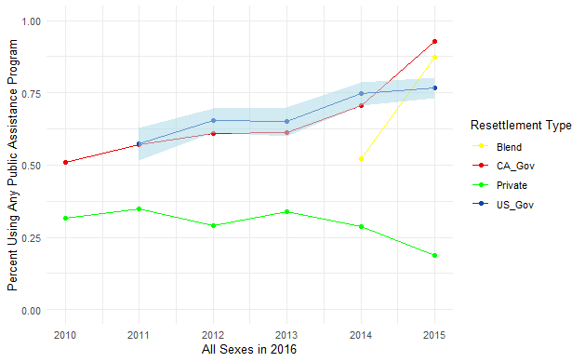 | 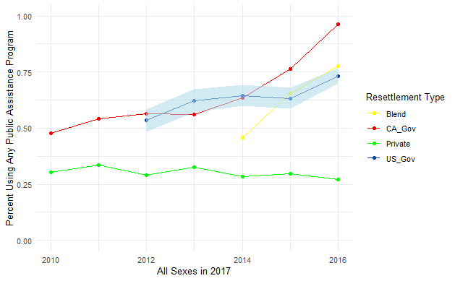
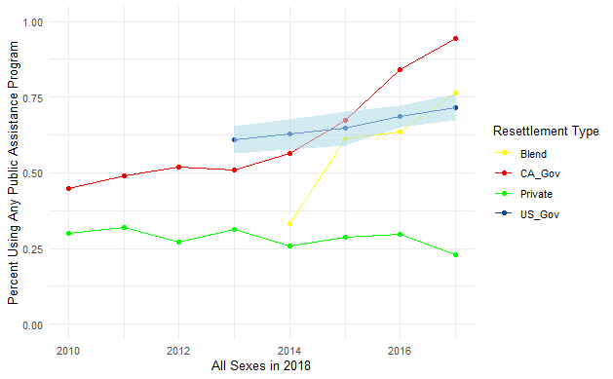 | 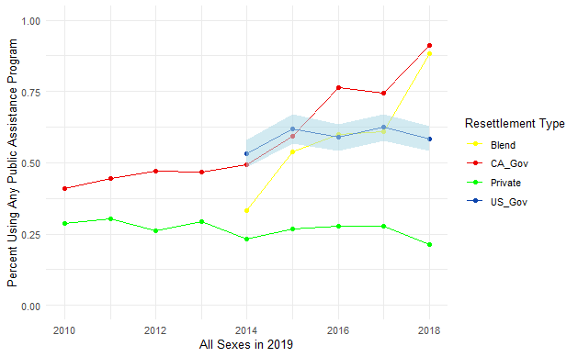
Note: Canadian data is from the Longitudinal Immigration DataBase is a complete accounting of tax payers and so has no margin of error. United States data is from the Annual Survey of Refugees.

There is an initial drop in public assistance program use over time and then a leveling out for the Canadian resettlement types, while the American resettlement route usually starts lower and declines moderately. At the end of five years, the proportion of households using public assistance programs is close.
Figure 2 describes the demographic results by sex for the 2016-2019 data. The male life tables tend to reflect the combined sex life tables very closely. The majority of households resettled in both countries are headed by men, which is why the combined sex life tables look so much like the male life tables. Women-headed households, especially the women-headed households sampled in the United States, had more variance. This is likely because the female-headed household is rarer: typically only making up around 25% of the Annual Survey of Refugee’s 1500 households. It is hard to tell which sex had higher assistance program use rates at the end of five years, especially because it seems to change based on the resettlement system. The model-based approach will obtain estimates for sex and observe the effects of sex across each resettlement system.
FIGURE 2. Public Assistance Use Rates by Sex, 2016-2019 Combined.
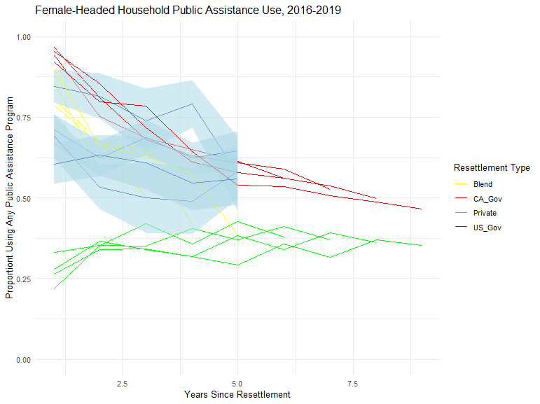 | 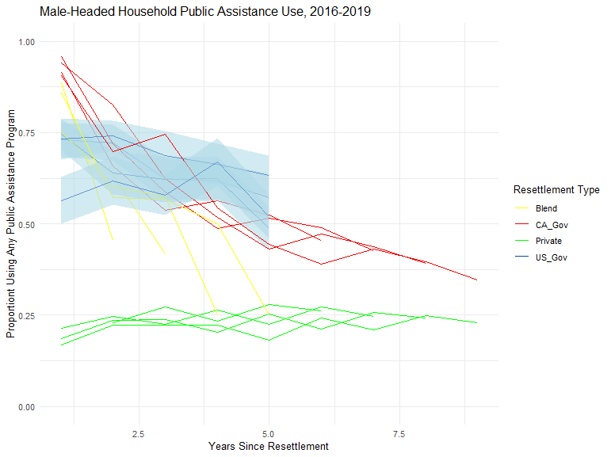

Because funding is only available at the country level, I cannot disentangle the funding per program, nor the distribution of funds across household characteristics like sex. However, when we look at the funding per capita available in each country it is clear that Canada spends much more per refugee than the United States does, often several times over. The total spending of the countries is similar, but the United States resettles many more refugees than Canada.
TABLE 1. Grouped Funding Per Capita
Country | Reference Year | Mean Funding per Capita in 2016 U.S. Dollars
Canada | 2016 | $9,986
United States | 2016 | $1,615
Canada | 2017 | $7,584
United States | 2017 | $1,236
Canada | 2018 | $7,811
United States | 2018 | $1,622
Canada | 2019 | $8,512
United States | 2019 | $3,545
Canada | 2020 | $11,416
United States | 2020 | $6,114

I also created a multilevel model to analyze the public dependence ratio. First, the decision to use a multilevel model is supported by a null model with just the grouping variable, resettlement type, the grouping variable with just random intercepts accounts for about 70% of the total variance in public assistance use. This indicates that there is a lot of clustering at the grouping level and an ordinary least squares regression would not be able to account for this.
In the full model, I find a gender gap in households headed by women (they tend to use more public assistance programs). The model estimates that, on average, about 6.3% more of the female-headed households in the cohort are using public assistance programs than the male-headed households of the cohort. This is a moderate effect, like the effect of a cohort living another additional year in the country. For every year lived in the county, we expect an additional 5.5% of the cohort to be off of public assistance programs.
We will avoid interpreting the effects of the public assistance programs alone. Because of the interaction effect, these represent the effect of a program when the funding is 0, which is not possible.
When we consider the interaction of funding with the resettlement type, the Canadian private system stands out from the others, and especially stands out from the Canadian government-led program because I use this as the reference group for the interaction. The Canadian private track is the only resettlement program to differentiate itself form the Canadian government-led program. The cohorts that receive funding (which is all cohorts) and are in the private track can expect 7.2 percentage points lower public assistance program use than the Canadian government system.
The funding a government office receives appears to have a relationship with public assistance use outcomes, though disentangling agency funding from resettlement type is not possible with this data. The full model explains about 92% of the total variance in public assistance use. See Table 2.
TABLE 2. Summaries of a Null and Full Multilevel Model of the Percentage of Cohort Using Public Assistance Programs 2016-2020. Standard Errors in Parentheses.
Variable Name | Null Model | Full Model
(Intercept) | 55.6 (9.9) | 173.0 (61.0)
Years In Country |  | -5.7 (0.6)
Females(ref=Male-headed households) |  | 6.4 (1.3)
log(Initial funds per household) |  | -6.14 (4.9)
CA Blended Resettlement |  | 2.94 (52.6)
CA Private Resettlement |  | 21.0 (52.6)
U.S. Government Resettlement |  | -22.8 (58.7)
log(Initial funds per) × CA Blended |  | -1.5 (2.3)
log(Initial funds per) × CA Private |  | -7.0 (2.3)
log(Initial_funds_per) × US Gov |  | 1.36 (3.6)
Number of Observations | 217 | 217
R² Marg. | 0.000 | 0.24
R² Conditional | 0.72 | 0.95
AIC | 1722.8 | 1548.2
BIC | 1732.9 | 1619.2
ICC | 0.7 | 0.9
RMSE | 12.17 | 8.93
Notes: The full model includes the admission years as a control.

DISCUSSION
I started this analysis with three hypotheses: 1) That refugee cohorts with greater funding per capita would do better than cohorts with less funding per capita. 2) That the Canadian and U.S. government-led resettlement systems would have similar outcomes. And 3) That private resettlement programs should have lower public assistance use rates than the other resettlement types.
While most hypotheses were supported, I found evidence against hypothesis 1. The U.S. has far lower funding allocated per capita. Canada often has multiple times as much funding per capita than the United States, and yet—supporting hypothesis 2— we see no meaningful difference in the five-year outcomes in government-led public assistance use in the life table analyses nor in the multilevel analysis which considers all the years and not just the fifth-year outcome. The government-led assistance programs in both countries could not be differentiated statistically in the model.
There a couple exceptions, or limitations, to Canadian/U.S. equivalence. Canada has a few variations on government-led resettlement, most importantly they support their refugees for a full year while the U.S. for only a couple of months. The next difference is in the resettlement programs that have a private component. The Blended and Private systems have lower public assistance program usage rates than either government-led resettlement program. The size of this effect was large, usually more than 10 percentage points. This supported hypothesis 3. No evidence contradicted hypothesis 3.
These findings need to be contextualized. I cannot see how these short-term outcomes could relate to long term outcomes, nor the lower-level interactions between citizens or refugees. I cannot identify the funding per resettlement program, I do not have access to the race and ethnicity data on the Canadian side and work that could incorporate this would be more in line with other economic studies.
It would be wrong to assume that funding has no relationship with public assistance use. Instead, we see no difference between the U.S. which has much lower per capita funding than Canada, which has higher, in the short term. The arguments raised by researchers focus on the long term. This study simply identifies that in the short term, we don’t see much gain increasing the funding per capita nor in increasing the duration of refugee specific support programs when other benefits like SNAP or TANF are available. It is probable that initial support will matter more for long term outcomes.
These results have urgent policy implications. Male-headed households are not using public assistance programs at the same rate as female ones. Perhaps this is an advantage or privileged male households have, or alternatively an unwillingness to use public assistance programs that may hold these households back in the future. The U.S. invests much less money into its government resettlement program per refugee but still receives comparable outcomes to the Canadian counterpart. Identifying why this might be the case beyond these exploratory thoughts can help governments be more efficient. Additionally, the superior outcomes of the private assistance program are a good sign for the start of the U.S. private resettlement route in 2023: the Welcome Corps. The Welcome Corps is the American private resettlement system set up after the Canadian model. Five citizens/permeant residents can band together to support refugees for 90 days in the stead of the State Department. The whole U.S. Refugee Assistance program, including the Welcome Corps, is currently suspended and under review for its existence due to the Trump administration’s “Executive Order on “Realigning the United States Refugee Admissions Program” (The White House 2025). This is unfortunate, as the U.S. resettlement program is not only the largest resettler of refugees, but also the most efficient government-led resettlement in per capita spending. Based on this evidence, the Welcome Corp is likely even more efficient and with better outcomes.

REFERENCES
Bernstein, Hamutal. 2018. “Bringing Evidence to the Refugee Integration Debate.” Urban Institute, April 5.
Bloemraad, Irene. 2011. “‘Two Peas in a Pod,’ ‘Apples and Oranges,’ and Other Food Metaphors: Comparing Canada and the United States.” American Behavioral Scientist 55(9):1131–59. doi: 10.1177/0002764211407844.
Bloemraad, Irene. 2013. “The Promise and Pitfalls of Comparative Research Design in the Study of Migration.” Migration Studies 1(1):27–46. doi: 10.1093/migration/mns035.
Bose, Pablo S. 2020. “The Shifting Landscape of International Resettlement: Canada, the US and Syrian Refugees.” Geopolitics. doi: 10.1080/14650045.2020.1781820.
Bureau of Labor Statistics. 2024. “Consumer Price Index for All Urban Consumers.” Retrieved (https://data.bls.gov/timeseries/CUUR0000SA0).
Bureau of Population, Refugees, and Migration. 2016. “Congressional Presentation Document.”
Camarota, Steven A. 1999. Importing Poverty: Immigration’s Impact on the Size and Growth of the Poor Population in the United States. Washington, D.C.: Center for immigration Studies.
Camarota, Steven A. 2021. “Welfare Use for Immigrants and Native-Born Households.” CIS.Org. Retrieved December 11, 2024 (https://cis.org/Camarota/Welfare-Use-Immigrants-and-NativeBorn-Households).
Capps, Randy, Kathleen Newland, Susan Fratzke, Susanna Groves, Michael Fix, Margie McHugh, and Gregory Auclair. 2015. The Integration Outcomes of U.S. Refugees: Successes and Challenges.
Connor, Jynnah Radford and Phillip. 2019. “Canada Now Leads the World in Refugee Resettlement, Surpassing the U.S.” Pew Research Center. Retrieved September 28, 2024 (https://www.pewresearch.org/short-reads/2019/06/19/canada-now-leads-the-world-in-refugee-resettlement-surpassing-the-u-s/).
Coyne, Christopher J. 2013. Doing Bad by Doing Good: Why Humanitarian Action Fails. First Edition. Stanford (Calif.): Stanford University Press.
DeSipio, Louis. 2011. “Immigrant Incorporation in an Era of Weak Civic Institutions: Immigrant Civic and Political Participation in the United States.” American Behavioral Scientist 55(9):1189–1213.
Donato, Katharine M., and Elizabeth Ferris. 2020. “Refugee Integration in Canada, Europe, and the United States: Perspectives from Research.” Annals of the American Academy of Political and Social Science 690(1):7–35. doi: 10.1177/0002716220943169.
Evans, William N., and Daniel Fitzgerald. 2017. The Economic and Social Outcomes of Refugees in the United States: Evidence from the ACS. w23498. National Bureau of Economic Research. doi: 10.3386/w23498.
Fix, Michael, Kate Hooper, and Jie Zong. 2017. “How Are Refugees Faring? Integration at U.S. and State Levels.”
Food and Nutrition Service of the U.S. Department of Agriculture. 2024. “SNAP Eligibility for Non-Citizens.” Retrieved December 11, 2024 (https://www.fns.usda.gov/snap/recipient/eligibility/non-citizen).
Hayek, F. A. 1945. “The Use of Knowledge in Society.” The American Economic Review 35(4):519–30.
Immigration, Refugees, and Citizenship Canada. 2010. “Reasons You May Be Inadmissible to Canada.” Retrieved December 11, 2024 (https://www.canada.ca/en/immigration-refugees-citizenship/services/immigrate-canada/inadmissibility/reasons.html).
Immigration, Refugees and Citizenship Canada. 2023. “Immigration, Refugees and Citizenship Canada Departmental Plan 2019-2020.” Retrieved December 10, 2024 (https://www.canada.ca/en/immigration-refugees-citizenship/corporate/publications-manuals/departmental-plan-2019-2020/departmental-plan.html).
International Organization For Migration. 2023. “Refugees and Asylum-Seekers.” World Migration Report. Retrieved September 28, 2024 (https://worldmigrationreport.iom.int/what-we-do/world-migration-report-2024-chapter-2/refugees-and-asylum-seekers).
Kneebone, Susan, and Felicity Rawlings-Sanaei, eds. 2007. New Regionalism and Asylum Seekers: Challenges Ahead. 1st edition. New York: Berghahn Books.
Lavoie, Don. 2016. National Economic Planning: What Is Left? 1st edition. Arlington, Virginia: Mercatus Center at George Mason University.
Nam, Yunju, Amanda Hausmann, Wooksoo Kim, and Sarah Richards-Desai. 2021. “Welfare-Dependent Refugees?: Evidence from County Welfare Management System Data in Western New York.” Journal of Immigrant & Refugee Studies 0(0):1–14. doi: 10.1080/15562948.2021.1923880.
Phillimore, Jenny. 2020. “Refugee-Integration-Opportunity Structures: Shifting the Focus from Refugees to Context.” Journal of Refugee Studies (12). doi: 10.1093/jrs/feaa012.
Scholes, Paul. 2022. “Do Refugees Who Become Economically Self-Sufficient Start with Nothing?” Retrieved December 12, 2024 (https://www.proquest.com/openview/2d29283d74124455779494318db0554c/1?pq-origsite=gscholar&cbl=18750&diss=y).
Strang, Alison, and Alastair Ager. 2010. “Refugee Integration: Emerging Trends and Remaining Agendas.” Journal of Refugee Studies 23(4):589–607. doi: 10.1093/jrs/feq046.
Sumption, Madeleine. 2013. “Tackling Brain Waste: Strategies to Improve the Recognition of Immigrants’ Foreign Qualifications.”
Teixeira, Carlos, and Wei Li. 2009. “Immigrant and Refugee Experiences in North American Cities.” Journal of Immigrant & Refugee Studies 7(3):221–27. doi: 10.1080/15562940903150030.
The White House. 2025. “Realigning the United States Refugee Admissions Program.” The White House. Retrieved January 24, 2025 (https://www.whitehouse.gov/presidential-actions/2025/01/realigning-the-united-states-refugee-admissions-program/).
Tran, Van C., and Francisco Lara-García. 2020. “A New Beginning: Early Refugee Integration in the United States.” RSF: The Russell Sage Foundation Journal of the Social Sciences 6(3):117–49. doi: 10.7758/RSF.2020.6.3.06.
UNHCR Canada. 2024. “Refugee Resettlement to Canada.” UNHCR Canada. Retrieved December 12, 2024 (https://help.unhcr.org/canada/refugee-resettlement-to-canada/).
United States Department of State. 2021. “Reception and Placement.” United States Department of State. Retrieved October 28, 2021 (https://www.state.gov/refugee-admissions/reception-and-placement/).
United States Office of Refugee Resettlement. 2021. Annual Report to Congress 2018. Office of Refugee Resettlement.
U.S. Department of Homeland Security. 2022. “Public Charge Ground of Inadmissibility.” Federal Register. Retrieved December 11, 2024 (https://www.federalregister.gov/documents/2022/09/09/2022-18867/public-charge-ground-of-inadmissibility).
U.S. Department of the Treasury. 2024. “Treasury Reporting Rates of Exchange.” Retrieved (https://fiscaldata.treasury.gov/datasets/treasury-reporting-rates-exchange/treasury-reporting-rates-of-exchange).

